DROP-IN SERVICE & SUPPORT FOR WOMEN
CONCERNING DOMESTIC ABUSE

Do you feel unsafe in your home?
Independent and Confidential Domestic Abuse Advice
Confidential Service

National Domestic Abuse Helpline.
08002000247 runs 7 days a week /24hrs.

Social Welfare Advice from CAW

FREE Legal Advice
Housing Advice

Starts from 27th April 2022

WHEN: Every Wednesday 10:00am – 12:30 (No appointment needed)
WHERE:
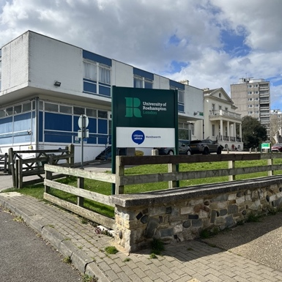
Picasso Building, Minstead Gardens, Roehampton SW15 4EE
Please ring CAW bell! 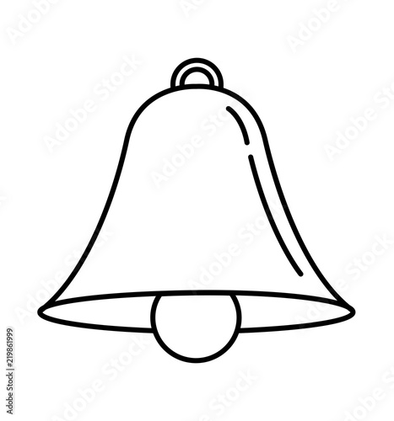
Phone: 0300 330 1169

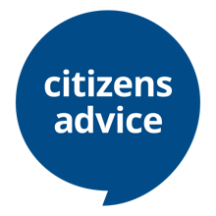
All Welcome!
We are here to help!

