Advice First Aid:
Building trust, Developing capacity,
and
Making connections.

Our experience in delivering Advice First Aid (AFA)
In 2016 we launched our Hardship Crisis project of which AFA became a key component. Funded by the Big Lottery Community fund, the project was delivered in partnership with WCEN and designed in recognition of two key facts: Firstly, we can never meet demand for our services, and Secondly, people in need of advice often don’t come to advice centres – instead preferring to seek help from trusted people from within their own community.

Our project’s aims and delivery methods were co-produced with faith and community groups in our borough. We listened to their descriptions of hardship, their views of us, and responded to their stated need for capacity-building support. We have delivered AFA since 2016. Over 100 people (in 11 cohorts) have received the general 2 day training, with many more attending our bite-size specialist subject sessions. We have a great deal of evaluation data (which we have used to continually improve the programme) including the graph below:

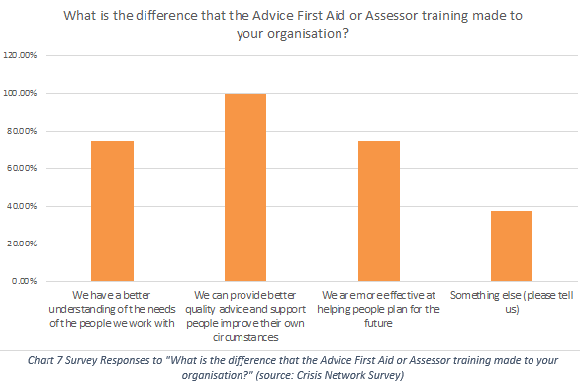

Network events
In addition to AFA we host at least two network events a year; these are large events where we discuss a specific topic (in response to requests from partners). Commonly, we present a rights-based introduction to the topic (like UC, or school exclusions) and then facilitate discussions between statutory and non-statutory guests. The idea being that both sides learn from hearing the voices of each other.

Conferences
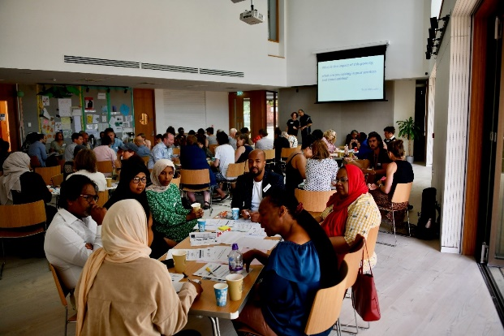 | We bring together AFA project partners with local policy  makers at our annual Hardship Crisis conferences. At these events we look at the impact of poverty in our borough, and  how we can work together to address it. We also talk about  the impact of AFA - including by hearing directly from clients.

Impact on partnership
Through AFA delivery we have developed a network which has strengthened partnerships across the borough. AFA builds trust in our services, but it also builds trust between services across the borough. We also host a referral platform which facilitates AFA partners to refer to each other as well as to us; preventing residents falling between the cracks in services.

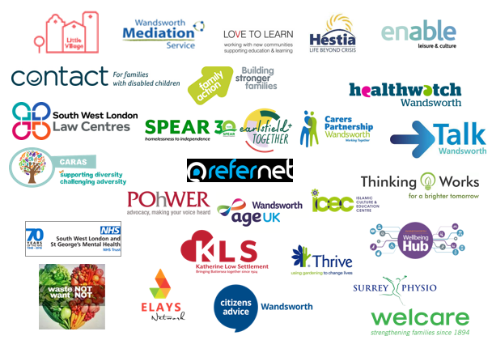 | 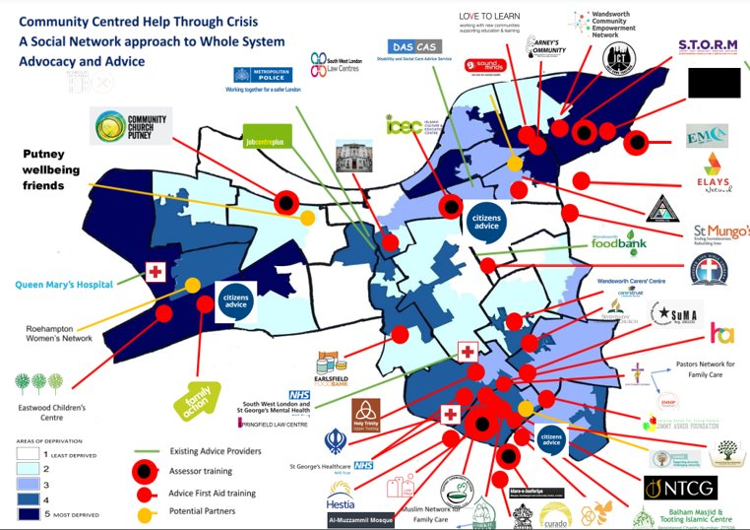

Other relevant information
Local Citizens Advice across England have built on our success to deliver AFA in their areas (following attendance at events where we have described our approach).

In 2019 we won the national Citizens Advice Championing Equality award for our AFA project.
‘The nature of AFA training is to instruct people about key social issues such as school exclusion, debt, housing, benefits, immigration and how to tackle these issues to make people’s lives better. Effectively AFA training can tell people about their rights. As more people are trained, more people have rights-based knowledge about their entitlements. Increasing awareness about rights and entitlements contributes towards empowering communities in general. Over time this, and the capacity building of community organisations will result in greater social cohesion and more socially active communities. It might not yet be possible to talk about a ‘movement’ of AFAs or socially active communities but overtime as this model is rolled out more widely, this will increasingly be the case.
The Help Through Hardship Crisis project has potentially delivered a new model for providing advice and support that up-ends existing models, broadening out access and support’.

Robin Brady 2022 - Final Evaluation of the Help Through Hardship Crisis Project

An AFA cohort of trainees

